**Overview of Failover and Backup**

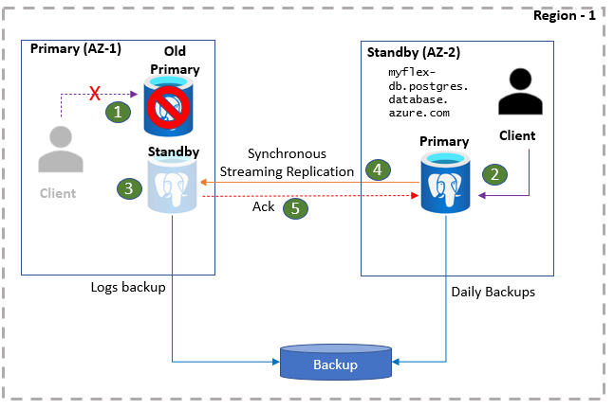

1. Primary database server is down and the clients lose database connectivity.
2. Standby server is activated to become the new primary server. The client connects to the new primary server using the same connection string. Having the client application in the same zone as the primary database server reduces latency and improves performance.
3. Standby server is established in the same zone as the old primary server and the streaming replication is initiated.
4. Once the steady-state replication is established, the client application commits and writes are acknowledged after the data is persisted on both sites.

* Flexible servers configured with zone-redundant high availability provide a recovery point objective (RPO) of Zero (no data loss). The recovery time objective (RTO) is expected to be less than 120s in typical cases. However, depending on the activity in the primary database server at the time of the failover, the failover may take longer.
* After the failover, while a new standby server is being provisioned (which usually takes 5-10 minutes), applications can still connect to the primary server and proceed with their read/write operations. Once the standby server is established, it will start recovering the logs that were generated after the failover.
* **Performing Planned Failover over the postgres database :**

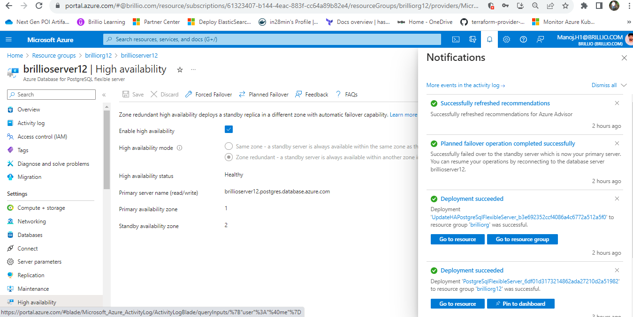

* **Performing forced failover on Postgres database :**

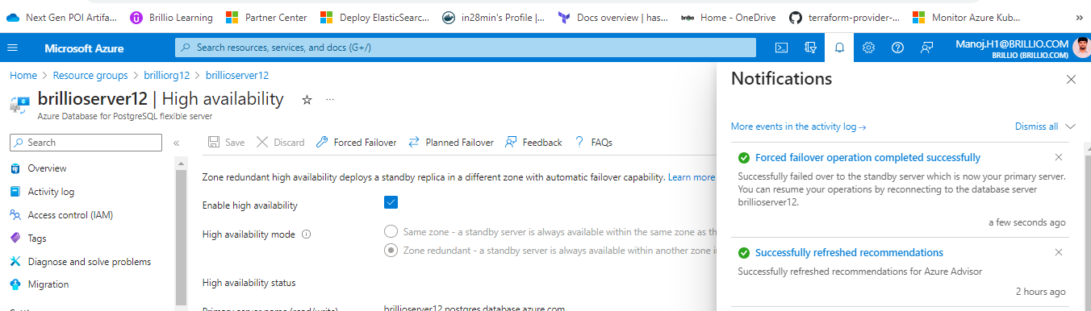

Referred document : https://learn.microsoft.com/en-us/azure/postgresql/flexible-server/concepts-high-availability.